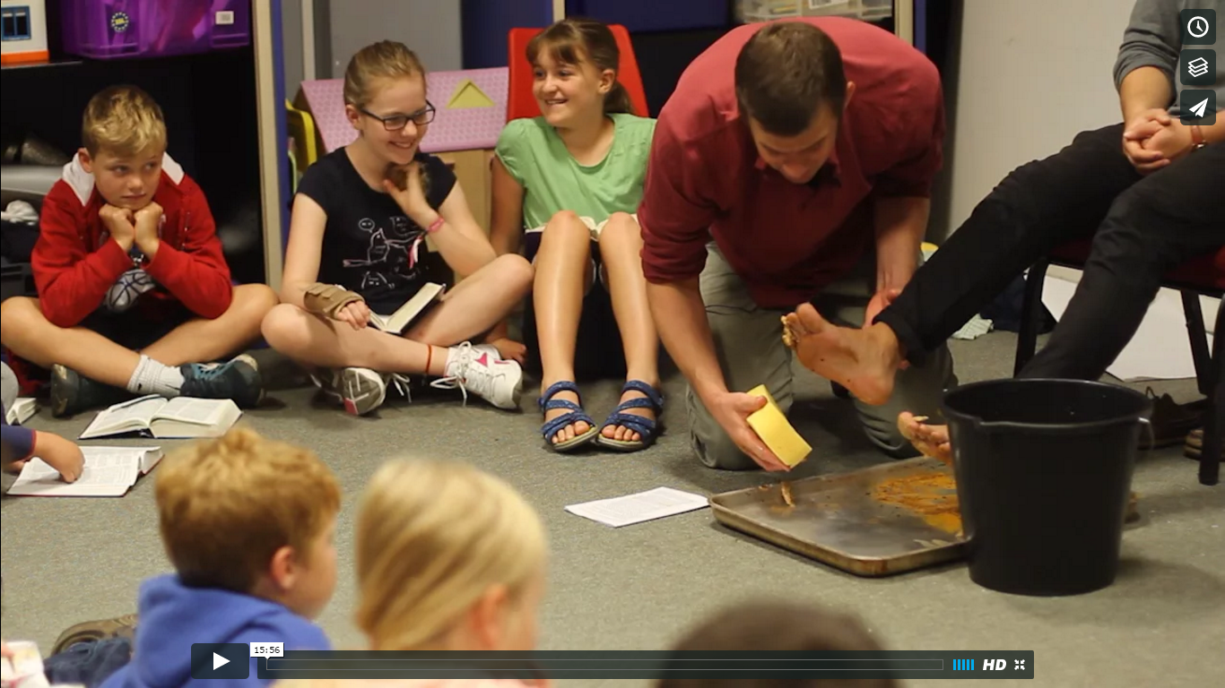

[Click to watch video](https://vimeo.com/187622104)

[Presents: Training video teaching a group of 9-11 year olds.](https://vimeo.com/187622104)

To view the video you will need this password: Matthew 19:14

Any questions? Send us an [email](mailto:faithinkids@co-mission.org).

The Faith in Kids team